# RAN EMS

U2020 Configuration Management (5G Riders Catalyst), No Environment

<https://documenter.getpostman.com/view/132405/S1LsXVYG#3a3a7a75-0298-44b3-bb2e-e7010f9b0319>

$ curl --location --request PUT https://4d394d39-024d-4d26-b4b4-ef04522fef4a.mock.pstmn.io/U2020/ran-transmission/backh

aul/7406859/backup/

{

"gNodeBId":7406859,

"backhaulMode":"integratedAccessBackhaul"

}

# Slice Management API

## Allocate Network

<https://documenter.getpostman.com/view/132405/S1LsXpZk#97b27fef-bf1a-42ca-8d58-2414cabd9e6d>

$ curl --location --request POST https://8b84a90d-bd20-440a-bfee-19912c29b57f.mock.pstmn.io/nsaas/slicemanagement/slice

s

{

"slice": {

"sliceId": "a0b0adf6-16aa-4157-abc0-d036f5c2fb2f",

"operationId": "31af59f1dc72437cb1c8f7"

}

}

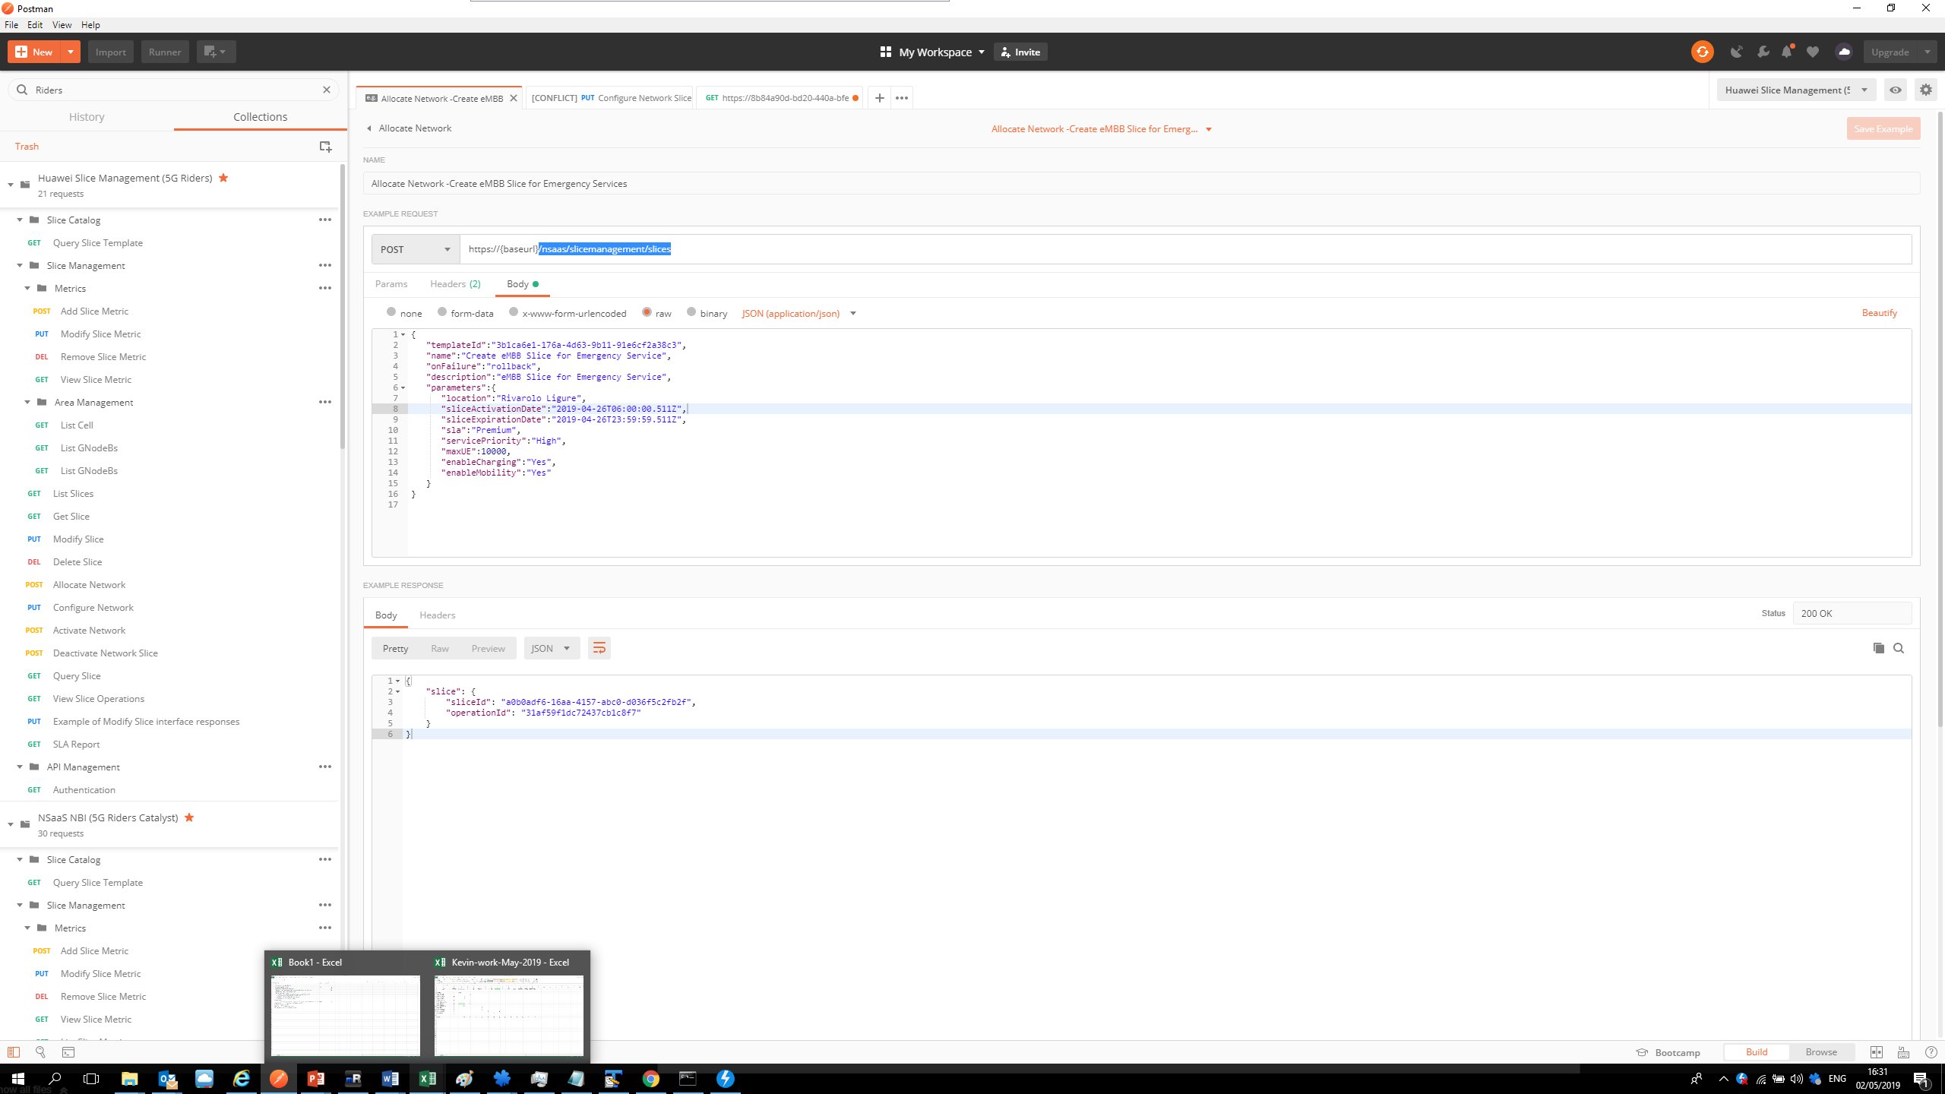

## Configure Network

$ curl --location --request PUT https://8b84a90d-bd20-440a-bfee-19912c29b57f.mock.pstmn.io/nsaas/slicemanagement/slices

/a0b0adf6-16aa-4157-abc0-d036f5c2fb2f/configure

{

"slice": {

"sliceId": "a0b0adf6-16aa-4157-abc0-d036f5c2fb2f",

"operationId": "31af59f1dc72437cb1c8f7",

"status": "configured"

}

}

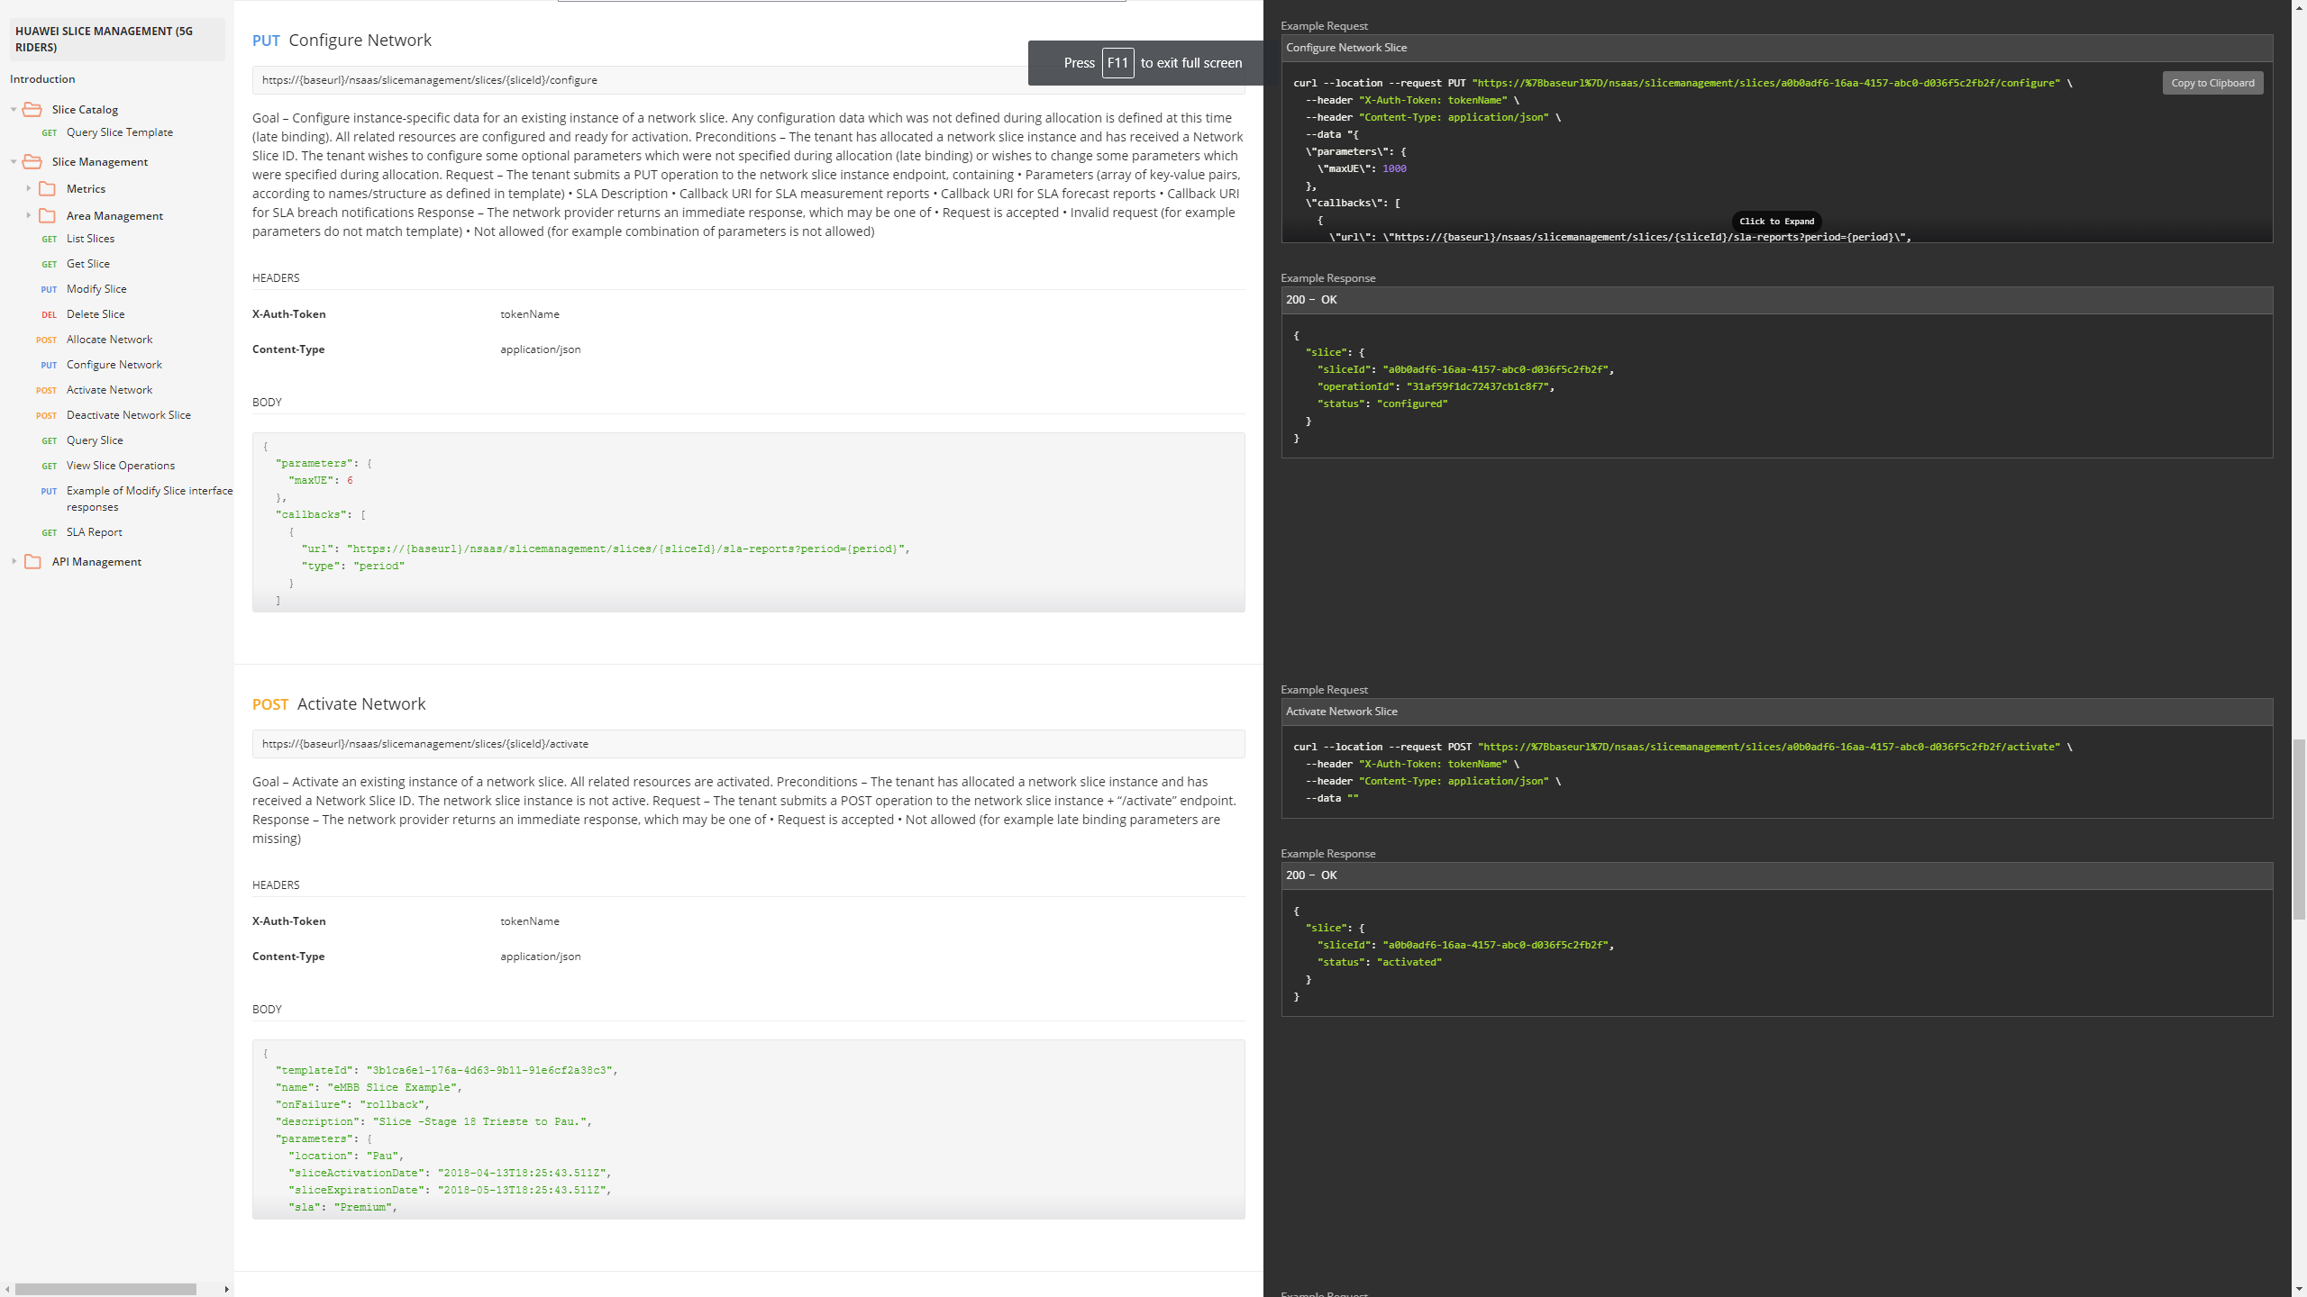

<https://documenter.getpostman.com/view/132405/S1LsXpZk#07843f4c-ba9f-4f6b-8835-1e9135dc8c2c>

## 1.3 Activate Network

curl --location --request POST https://8b84a90d-bd20-440a-bfee-19912c29b57f.mock.pstmn.io/nsaas/slicemanagement/slice

s/a0b0adf6-16aa-4157-abc0-d036f5c2fb2f/activate

{

"slice": {

"sliceId": "a0b0adf6-16aa-4157-abc0-d036f5c2fb2f",

"status": "activated"

}

}